Project Planning Phase

**Project Planning Template (Product Backlog, Sprint Planning, Stories, Story points)**

|  |  |
| --- | --- |
| Team ID | PNT2022TMID13652 |
| Project Name | Smart waste management system for metropolitan cities |
| Maximum Marks | 8 Marks |

Product Backlog, Sprint Schedule, and Estimation (4 Marks)

|  |  |  |  |  |  |  |
| --- | --- | --- | --- | --- | --- | --- |
| **Sprint** | **Functional Requirement (Epic)** | **User Story Number** | **User Story / Task** | **Story Points** | **Priority** | **Team Members** |
| Sprint-1 | Registration form | USN-1 | As an administrator need to give credentials to every sanitary workers over the cities to make them accessible to the APP to get real time data. | 20 | High | S.Sangeetha  P.Sankareswari  S.Nandhini devi  P.Swetha  M.Yasotha |
| Sprint-1 | Sign-up & sign-in form | USN-2 | As a user, I able to create account and I can login to the app by using credentials given and also I can able to sign-in the form once I had created the account. | 20 | High | S.Sangeetha  P.Sankareswari  S.Nandhini devi  P.Swetha  M.Yasotha |
| Sprint-2 | Technology | USN-3 | Design the circuit with processor, sensors, actuators which is to be integrated with the dustbin. | 5 | Low | S.Sangeetha  P.Sankareswari  S.Nandhini devi  P.Swetha  M.Yasotha |
| Sprint-2 | Cloud | USN-4 | Cloud web server is created using IBM cloud that connects the bin with the administrator to fetch real time data produced by the sensor embedded in that which helps in real time monitoring of trash in the dustbins. | 10 | Medium | S.Sangeetha  P.Sankareswari  S.Nandhini devi  P.Swetha  M.Yasotha |
| Sprint-2 | Cloud & GPS | USN-5 | The location of the bin was fetch using GPS connected to it. | 10 | Medium | S.Sangeetha  P.Sankareswari  S.Nandhini devi  P.Swetha  M.Yasotha |
| Sprint-3 | Sensor & technology | USN-6 | The level of the trash in the dustbin were monitored by the ultrasonic sensor embedded in that which will helps us to identify the overflowing of the dustbins. | 20 | High | S.Sangeetha  P.Sankareswari  S.Nandhini devi  P.Swetha  M.Yasotha |
| Sprint-4 | Alert notification | USN-7 | Once the dustbin were over-flown, immediate alert message including location of the bin were sent to the municipal officer regarding collection of wastes. | 15 | High | S.Sangeetha  P.Sankareswari  S.Nandhini devi  P.Swetha  M.Yasotha |
| Sprint-4 | Acknowledgement | USN-8 | After collecting the trash the sanitary worker intimates that the garbage has collected to the municipal officer using app | 5 | Low | S.Sangeetha  P.Sankareswari  S.Nandhini devi  P.Swetha  M.Yasotha |

Project Tracker, Velocity & Burn down Chart: (4 Marks)

|  |  |  |  |  |  |  |
| --- | --- | --- | --- | --- | --- | --- |
| **Sprint** | **Total Story Points** | **Duration** | **Sprint Start Date** | **Sprint End Date (Planned)** | **Story Points**  **Completed (as on Planned End Date)** | **Sprint Release Date (Actual)** |
| Sprint-1 | 20 | 6 Days | 24 Oct 2022 | 29 Oct 2022 | 20 | 29 Oct 2022 |
| Sprint-2 | 20 | 6 Days | 31 Oct 2022 | 05 Nov 2022 | 20 | 05 Nov 2022 |
| Sprint-3 | 20 | 6 Days | 07 Nov 2022 | 12 Nov 2022 | 20 | 12 Nov 2022 |
| Sprint-4 | 20 | 6 Days | 14 Nov 2022 | 19 Nov 2022 | 20 | 19 Nov 2022 |

Velocity:

Imagine we have a 10-day sprint duration, and the velocity of the team is 20 (points per sprint). Let’s calculate the team’s average velocity (AV) per iteration unit (story points per day)

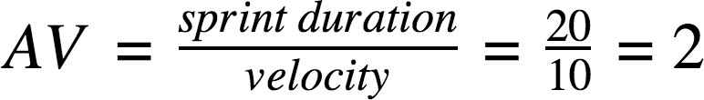

AV = 20/6 = 3.3

SPRINT-1

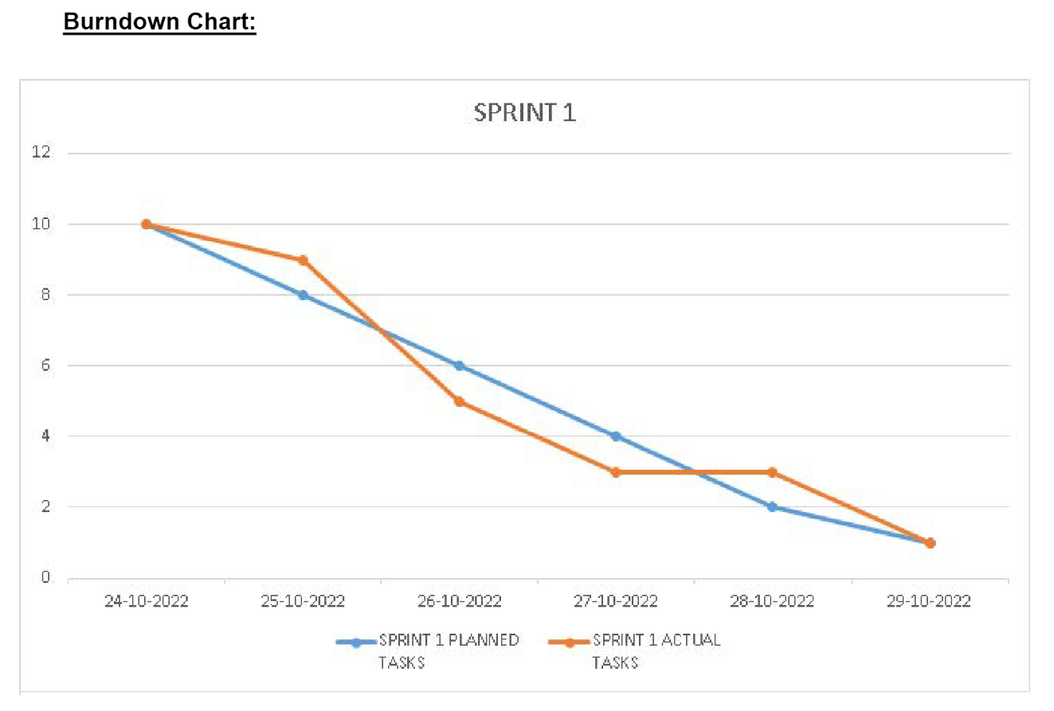

SPRINT-2

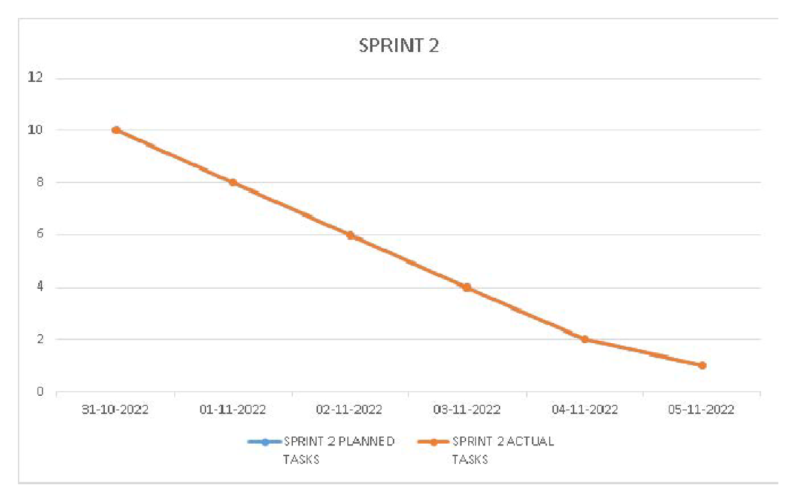

SPRINT-3

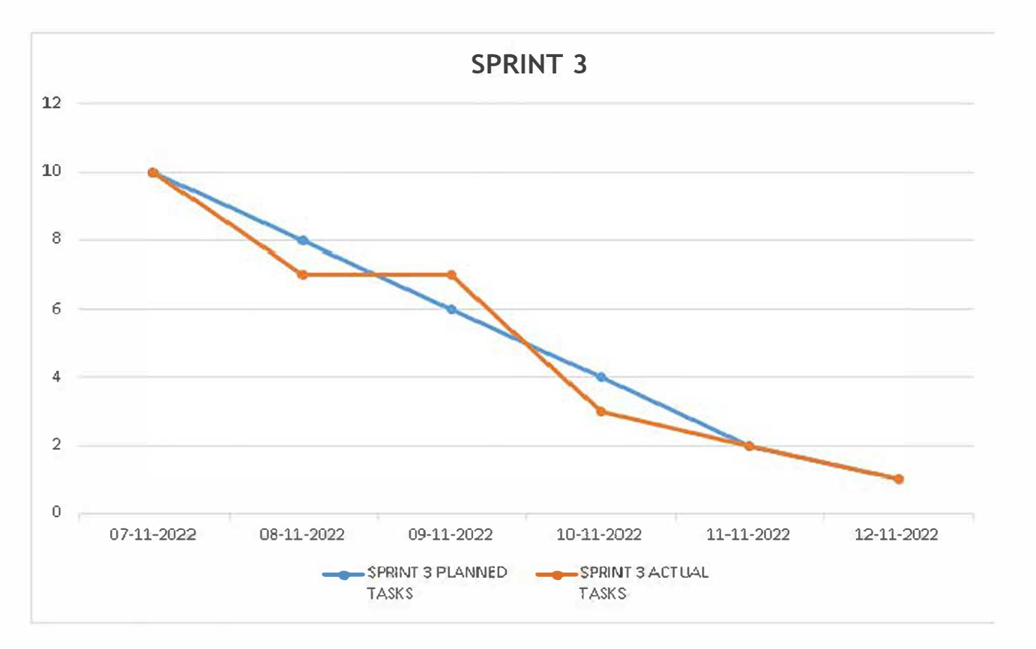

SPRINT-4

